BAMS Style Guide

These basic guidelines are intended to help provide document-wide consistency.

These guidelines follow style requirements of the Bulletin of the American Meteorological Society, which publishes the annual NOAA *State of the Climate Report*, as well as the *Chicago Manual of Style*.

**Table of Contents**

Language, Style, and Reference Considerations 2

General Text Formatting 2

Spelling, Punctuation, and Capitalization 3

Numbers 3

Date and Time Conventions 3

Latitude and longitude 4

Hyphenation 4

Acronyms 4

Author Information 4

In-text Author Citations 4

Figures 5

Tables 6

References 6

Submitting Figures to Graphics **7**

# Language, Style, and Reference Considerations

The working language of this report is English and all contributions must be in English. For authors for whom English presents some difficulty, those authors are advised to request an initial review of their submission from an English-speaking colleague. Alternatively, those authors may submit their draft submission to the editors at least one month before the deadline, to allow time for review and revision.

It is important that you write in a scientific style, and avoid colloquial wording in your text that many readers may not be familiar with.

Proper references in the AMS style must be included in the text (e.g., Doe and Doe 2005). All submissions must also include a reference list at the end of the submitted text in the AMS style format. Please see the [AMS guidelines for authors](http://web.archive.org/goodbye?src=http://www.ametsoc.org/pubs/authorsguide/html_vs/index.html) for complete information.

# General Text Formatting

Microsoft Word (.docx) is the preferred format.

Keep text formatting to a minimum, but please include super- and sub-script text formatting where appropriate. Following is additional text formatting information,

* Please follow the [AMS guidelines for authors](https://www.ametsoc.org/index.cfm/ams/publications/author-information/formatting-and-manuscript-components/).
* Text should be double-spaced and in Times New Roman 12-point font.
* Include a complete reference list at the end of the file.

Units/Dates/Symbols

* Use the International System of Units [Système Internationale (SI)].
* Units should have a space between each unit in a compound set (e.g., m s−2 rather than ms−2).
* Degree symbol: Do not use superscript ‘o’ instead of symbol. Do not include a space after the symbol, e.g., 150°E, 20°C
* For numbers with denominators, the format should follow AMS guidelines (e.g., mm day–1, not mm/day).
* Do not mix words and symbols for units (e.g., °C yr-1 rather than °C per year).
* Number–single-unit combinations used as modifiers should be hyphenated. For example, hyphenate 500 hPa when referring to the "500-hPa temperature."
* For unit ranges use the unit after both values (i.e., 15 m–20 m).
* See [AMS rules](https://www.ametsoc.org/index.cfm/ams/publications/author-information/formatting-and-manuscript-components/mathematical-formulas-units-and-time-and-date/) pertaining to mathematical formulas, units, and time and date.

# Spelling, Punctuation, and Capitalization

* Change Oxford English spellings to the appropriate American spelling except for proper names (such as the European Centre for Medium-Range Weather Forecasts).
* Use a serial comma before the conjunctions "and" or "or" in a list of three or more items.
* Northern Hemisphere, Southern Hemisphere, Eastern Hemisphere, and Western Hemisphere are all capitalized.
* The tropics, extratropics, and subtropics are written lowercase.
* Both “i.e.” and “e.g.” should have commas after them (i.e., use it this way).

# Numbers

* Spell out numbers zero through nine and write them as a numeral from 10 on.
* Spell out ordinal numbers first through ninth and right them as a numeral from 10th on.
* If a sentence includes numbers in the same context that are both above and below nine, the numeral form should be used throughout (i.e., "2 out of 14 cases" rather than "two out of 14 cases").
* Do not superscript the suffix used with ordinal numerals (i.e., “2nd” rather than “2nd”).
* If a number begins a sentence it must be spelled out.

# Date and Time Conventions

* Write dates in the form “29 March 1993.”
* Do not abbreviate months in the text.
* In figure captions and tables, abbreviate the month to its first three letters when it appears in a date (e.g., "23 Jan" or "17 Mar 2008") but spell it out in narrative uses in captions (e.g., “data cover January and February 2008”).
* Time, time zone, day, month, and year are written in the form “1409 UTC 29 March 1993.”
* Use of other time zones [e.g., EST, EDT, PST, LST (local standard time), or LT (local time)] is permissible, but they should be defined on first use.
* Use a colon to separate minutes from seconds (e.g., 0537:15 UTC).
* For year ranges, do not include the century in the second year unless a transition of centuries is spanned (e.g., "1988–92" but "1887–1932").
* Use a solidus (/) for indicating a transition for a period of less than two full years, and omit the century of the second year unless the century changes (e.g., "the 1988/89 winter," "the 1974/75 experiment period," but "1899/1900 winter").

# Latitude and longitude

* Express latitude and longitude pairs in that order for example, 41°N, 136°W.
* For locations on the globe at the equator, the Greenwich meridian, or 180° longitude, omit the hemisphere letter but not the degree symbol (e.g., 0°, 154°E; 33°S, 0°; or 57°N, 180°).
* For latitude and longitude ranges use the degree symbol and hemisphere letter after both values (i.e., 154°E–167°E).

# Hyphenation

* When talking about a range use the en dash (Unicode 2013) for example, “January–March” or “1876–1954.” The words “to” and “and” must be used instead of the en dash if the word proceeding the first part of the range is “from” or “between” respectively (i.e., “from January to March” or between “1876 and 1957”).
* In general words should be hyphenated when used as an adjective and should not be hyphenated when used as a noun (i.e., “a middle-class neighborhood” [adj] or “the neighborhood is middle class” [n]).

# Acronyms

* Spell out technical acronyms on first use in chapter or major section.This report will provide an Appendix of relevant acronyms and a link to full [AMS List of Acronyms](https://www.ametsoc.org/index.cfm/ams/publications/authors/journal-and-bams-authors/formatting-and-manuscript-components/list-of-acronyms-and-abbreviations/).
* If a term is not included in the AMS List, please spell out on first use.

# Author Information

* Provide a complete list of chapter authors, including full name and affiliation.
  + Example: Doe, Jane, University of the World, City, Country (State if in the U.S.)

# In-text Author Citations

Write in-text citations as follows:

* One author: “…substantial amounts of heat (Talley 2003)” OR “Talley (2003) states that….”
* Two authors: “…tropical cyclone development (Johnson and Birnbaum 2017)” OR “Per Johnson and Birnbaum (2017), tropical…”
* Multiple authors: “…ocean currents (Rhein et al. 2013)” OR “Rhein et al. (2013) found that…”

When listing multiple citations, note:

* If a parenthetical citation includes two or more papers, separate the citations with semicolons and list chronologically: (Forbes et al. 1999; Baker et al. 2001).
* If two or more citations by the same author(s) are listed consecutively, they should be combined: (Jones 1999, 2004; Jones and Tuller 2003, 2009; Jones et al. 2006, 2008).

**Personal communications and unpublished works:** There should be no “unpublished” or “submitted” papers included in this section in the final version; these may be included in the text only. Use “personal communication” (no italics) with the full name, primary affiliation of the author and year. Example: (Timo Vihma, Finnish Meteorological Institute, 2017, personal communication).

**Important**: Each in-text citation must have a corresponding reference, and vice versa.

**Exception:** Where a journal article has been submitted, but not yet accepted for publication the author should cite the work as (Doe and Doe 2006, submitted to *Imaginary Res.*). It will not yet have a corresponding reference.

# Figures

**Referencing figures in text:**

* All figures and tables should be cited in text and numbered in their order of appearance.
* In text, use the abbreviated form “Fig.” or “Figs.” except at the beginning of a sentence, where the word “Figure” is used.

For example:

Figures 4.2b,h further illustrate that 2017 was ….

and

… during these two seasons (Figs. 2a–c; 4c,d)

For review purposes, embed all figures and tables with their captions immediately after the References section. List one figure per page.

*Following is an example of how to write a figure caption*:

**Fig. #.#.** Place the figure caption below the figure. Begin caption with an overall descriptive statement of the figure followed by additional text. As noted above, figure parts are indicated with lowercase letters (a), (b), (c), etc. Panel descriptions should *lead* the text it describes, e.g., “Average (a) temperature and (b) pressure in Greenland” (and not “Average temperature (a) and pressure (b) in Greenland”).

*Following is an example of a figure and its caption*:

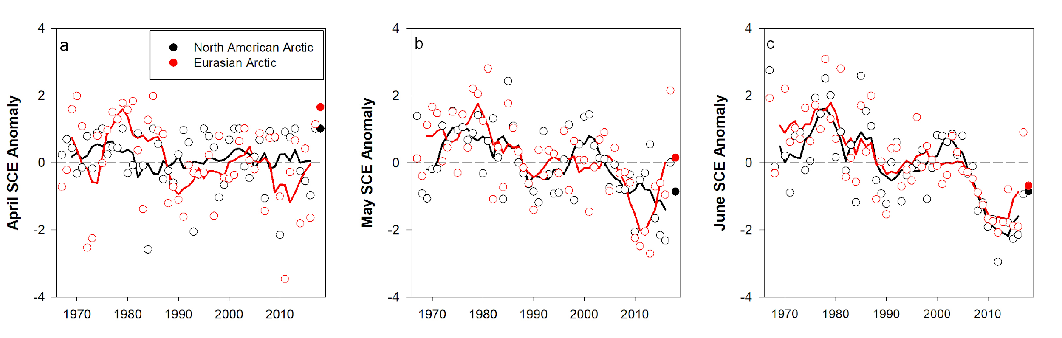

**Fig. 1.** Monthly snow cover extent (SCE) for Arctic land areas (>60°N) for (a) April, (b) May, and (c) June from 1967 to 2016. Anomalies are relative to the average for 1981–2010 and standardized (each observation differenced from the mean and divided by the standard deviation and thus unitless). Solid black and red lines depict 5-year running means for North America and Eurasia, respectively. Filled circles are used to highlight 2018 anomalies. Source: NOAA snow chart Climate Data Record (CDR).

# Tables

**Table #.#.** Start this caption with a short description of your table. Table captions appear above tables.

Tables must be editable; do not embed tables as images. Format tables using Word Table commands and structures. Do not create tables using spaces or tabs characters. For emphasized content, please use bold type and/or italics (not shading). For accessibility purposes, please keep the table as simple as possible, minimizing the use of merged cells. All columns should contain a heading. In column headings, please capitalize only the first word.

# References

All sources cited in text, tables, and figures must appear in the reference list, and all entries in the reference list must be cited in text.

**Journal articles:** Provide last name and initials of author(s) (), year of publication, title of paper, title of journal (abbreviated and *italicized*), volume of journal (**bolded**), issue or citation number, page range, and doi (if available). Examples follow.

Kanamitsu, M., W. Ebisuzaki, J. Woollen, S.-K. Yang, J. J. Hnilo, M. Fiorino, and G. L. Potter, 2002: NCEP–DOE AMIP-II Reanalysis (R-2). *Bull. Amer. Meteor. Soc.*, **83**, 1631–1643, https://doi.org/10.1175/BAMS-83-11-1631.

Rayner, N. A., D. E. Parker, E. B. Horton, C. K. Folland, L. V. Alexander, D. P. Rowell, E. C. Kent, and A. Kaplan, 2003: Global analyses of sea surface temperature, sea ice, and night marine air temperature since the late nineteenth century. *J. Geophys. Res.*, **108**, 4407, https://doi.org/10.1029/2002JD002670.

AMS journals are abbreviated as follows:

* Bulletin of the American Meteorological Society: *Bull. Amer. Meteor. Soc.*
* Earth Interactions: *Earth Interact.*
* Journal of Applied Meteorology and Climatology: *J. Appl. Meteor. Climatol.*
* Journal of Atmospheric and Oceanic Technology: *J. Atmos. Oceanic Technol.*
* Journal of Climate: *J. Climate*
* Journal of Hydrometeorology: *J. Hydrometeor.*
* Journal of Physical Oceanography: *J. Phys. Oceanogr.*
* Journal of the Atmospheric Sciences: *J. Atmos. Sci.*
* Monthly Weather Review: *Mon. Wea. Rev.*
* Weather and Forecasting: *Wea. Forecasting*
* Weather, Climate, and Society: *Wea. Climate Soc.*

# Submitting Figures to Graphics

For publication purposes, submit **high-resolution** figures only. *Please include the corresponding figure number in the file name*.

The following file formats are acceptable for figures:

* Postscript (.ps) - *preferred*
* Encapsulated Postscript (.eps)
* Uncompressed Tagged Image File Format (.tif) - 300 dpi resolution minimum at 100% of displayed size.
* Portable Network Graphics (.png)
* Adobe Illustrator (.ai)

Note: Make sure your file is a true vector file. Resaving a raster file, such as a .jpg or .gif, to a post script will not convert the image into a true vector file. Only the naming extension is changed.

Figures should follow these basic guidelines:

* Information on the figure should be readable when the figure is reduced to 3" x 3" (7.5 cm x 7.5 cm).
* Arial font should be used for any text, numbers, and labels.
* Font size should be minimum of 9-point font.
* All line widths must be a minimum of 1-point.
* Degree symbols should accompany all temperature and latitude/longitude numbers
* Figure titles should NOT be included on the figure.
* Legends should be placed off to the side if possible.
* SI units should be used on figure axes.
* Negative exponents should be used to describe something "per" something (e.g., use m s−1 instead of m/s or instead of meters per second).
* For multi-panel figures, label (a), (b), (c), etc from left to right by row and place in upper left corner of panel.

Color Selection:

* Colors or color schemes that do not reproduce well in gray-scale should be avoided.
* The combination of red and green on a figure should be avoided (for colorblindness).
* Green-to-Tan (wet-to-dry) color ramp is preferred for precipitation figures.
* Red-to-blue (hot-to-cold) color ramp is preferred for temperature figures.
* Bold colors are preferred for time series plots.

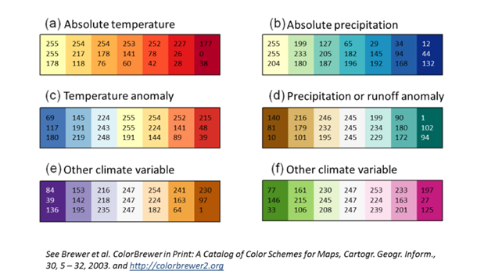

Note that [ColorBrewer](https://colorbrewer2.org/#type=sequential&scheme=BuGn&n=3) allows options to select colorblind friendly choices. If you would like more information or other options, please reach out to the editorial team.

We will change the colors (or ask for a revision) if the colors are not the best choice. If you have questions please contact us before doing several figures in the same color scheme.

When creating maps with a text overlay be sure to save the text layer separate. This will allow the text to be editable so we can change it to match the publication styles as needed.